OVERVIEW OF THE NIGERIA NATIONAL NUTRITION DATA AND RESULTS CONFERENCE [HYBRID] HELD ON 11TH - 13TH OCTOBER, 2022 IN ABUJA

The Federal Ministry of Finance, Budget and National Planning in collaboration with the Federal Ministry of Health, National Primary Health Care Development Agency, the World Bank and a number of Development Partners convened the National Nutrition Data and Results Conference on 11th to 13th October, 2022 at the Well Carlton Hotels and Apartment, Asokoro Abuja and the Banquet Hall, State House, Abuja Nigeria. The theme of the Conference was “Progress and New Opportunities Towards Strengthening the Nutrition Data Value Chain in Nigeria.”
The objectives of the conference were to introduce new initiatives, partnerships, and opportunities to strengthen the nutrition data generation and utilization in Nigeria; improve the framework for nutrition multi-sectoral coordination and financing; and share results of emerging trends and evidence from the Government’s flagship Accelerating Nutrition Results in Nigeria (ANRiN) Project.
Over 500 participants attended the Conference which was hybrid and these included representative of the Vice President, Governors and their representatives, Honorable Ministers, Ministers for State and Permanent Secretaries from the Federal Ministries of Finance, Budget and National Planning, Federal Ministry of Agriculture and Federal Ministry of Health, representatives of the World Bank, UNICEF, Bill & Melinda Gates Foundation, Aliko Dangote Foundation, USAID, Foreign Commonwealth Development Office, Nutrition International, GAIN and Data DENT. Other participants at the Conference included directors and programme officers from government Ministries, Departments and Agencies (MDAs) at national and sub-national levels, Nutrition Society of Nigeria (NSN), members of the academia, Civil Society Organizations and the media.
The Honorable Minister of State, Budget and National Planning, Prince Clement Agba while opening the Conference said the Buhari-led administrations is committed to ending malnutrition in line with the Sustainable Development Goal, SDG 2; Zero Hunger. The Minister noted that Federal Government has recorded remarkable investments and advancements along the nutrition data value chain despite the negative impacts of the COVID-19 Pandemic.
“It is worth restating that the negative effect of the COVID-19 pandemic which Nigeria has its fair share, has contributed to our challenges in addition to the impact of climate change and the security challenges that the country has experienced in recent years. These are pointers to the need for swift actions if we must meet the SDG 2 on Zero Hunger,” he said.
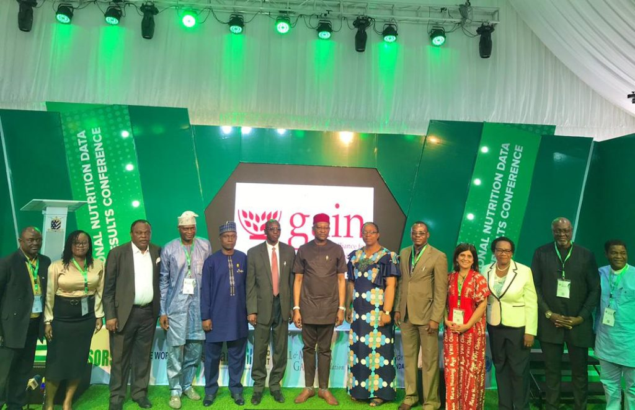
During the three days, government officials, academia, researchers, donors, implementing partners and development experts brainstormed on how best to align nutrition data generation and utilization at all levels, improve the framework for nutrition multi-sectoral coordination and financing as well as collaborate to achieve the national nutrition goals. Nutrition Stakeholders also reviewed the milestones achieved in the nutrition chain and identified how best the results could apply to policy formulation as well as decision making.
At the end of the Conference, a Communique was issued containing a summary “Call to Action” listing steps to advancing the Nigeria nutrition data value chain as well the nutrition multi-sectoral coordination and implementation within the framework of the National Multisectoral Plan of Action for Food and Nutrition which forms the basis for alignment and coordination around nutrition data quality, utilization, financing, and budget tagging and tracking.
Below is a summary of the “Call to Action” as contained in the communique:
- Develop a multisectoral framework for nutrition investment in Nigeria.
- Convene stakeholders under a nutrition data alliance to support nutrition framework operationalization.
- Accelerate nutrition results from paper based to digital space
- Strengthen and deepen nutrition data collection, collation, analysis and use through collective collaboration.
- The stakeholders within the value chain to come up with an MoU that will help articulate proposal on sugar sweetened beverages taxation bill to help in the reduction of sweetened beverages consumption.
- Nutrition Budget allocation should be prioritized taking advantage of the Fiscal Policy unique window opportunity of the Federal Government to enable full implementation the National Multisectoral Plan of Action for Food and Nutrition while ensuring accountability and access to information.
- There should be robust consumer awareness campaign on food fortification
- The nutrition scorecard designed by the Nigerian Governors’ Forum should be replicated at all tiers of government.

